Millwood Elementary School Advisory Council Meeting
March 4, 2026

Type of Meeting: Regular Business Chair: Michelle Barnhill Note taker: Nancy McNeil
Membership/Attendance:

Parent Members | Community Members | Staff Members | Administration
Joann Nolan  Michelle Barnhill  (Chair) | Susan Harris  Emily MacLeod  Amanda Guitard  Pam King | Traci George (X)  Angie MacAloney  Nancy McNeil  Tanya Pottie (X) |  | Janet Roy  (Principal)  Christine Richardson  (Vice Principal)

Record of Decisions:
Agenda Items | Summary | I-Information  D-Decision  A-Action
- Approval of the Agenda/Approval of minutes  Lead: Michelle | Meeting was called to order at 6:40pm.  Emily motioned for the approval of the meeting minutes from January 28, and Pam seconded the motion. Minutes were approved. Amanda motioned for approval of the agenda and Emily seconded the motion. | I  D
- Items Brought Forward  Lead: Michelle | None at this time | I
- Principal’s Report / SSP Update  Lead: Michelle | African Heritage Month: The highlight of the month was seeing our classes come together to present their learning. It wasn't just about reading history; it was about students taking ownership of these narratives and presenting them to their peers through art, research, storytelling and song. We focused specifically on the diverse legacies of Notable African Nova Scotians, bridging the gap between historical civil rights and modern-day excellence. Students gained a deeper sense of pride and a more complete understanding of our shared provincial identity.  Staffing Update: We have hired a new administrative assistant, Allison Hagen. She will be with us in a term position until the end of June.  SSP: Our Literacy consultant joined us for 2 staff meetings as we worked on deepening our understanding of Strand A of the New Language Arts Curriculum and gathering evidence to support implementation.  We also just received our January P-2 Data from CBAS. We will be analyzing this data and determining our next steps regarding interventions for students who are not meeting, with emphasis on our students of African and Indigenous descent.  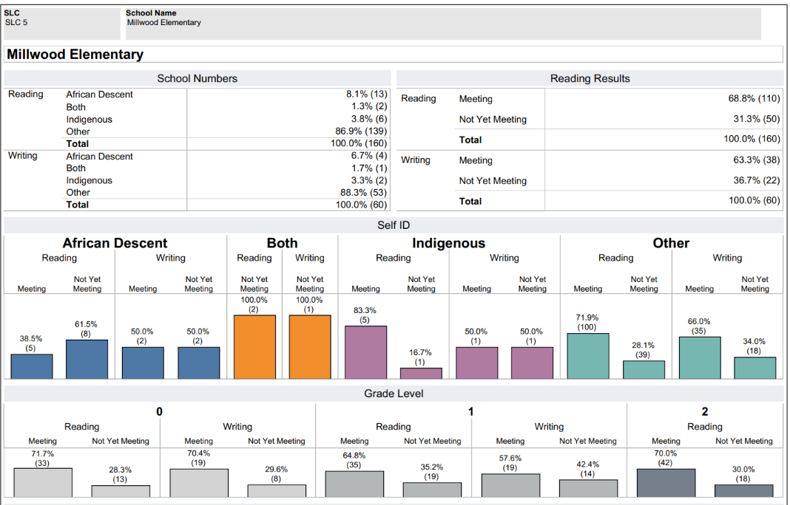  Incident Reporting: Our top 3 incidents being reported are: Interruption of the Learning environment, Physical Violence, and Insubordination.  Gender: 75%-Males, 25% Female  Time of Day: Afternoon Instruction-32%, Late Morning Instruction (after recess)-28%  Location: Classroom, Outside, Hallway  We will be discussing this data with staff and looking at action steps and proactive strategies that can be taken to decrease the number of incidents occurring.  Cookie Kits  The cookie kits received great feedback from those families that purchased them. The kits were made in conjunction with staff from RBC, who gave funding to our Schools Plus staff to use toward student programming. | I  I  I  I
- Wellness Update  Lead: Michelle | MES will be having a Spirit Week next week, for the four days before March Break. Information on the theme days will be sent home to families before Monday. | I
- SOS  Lead: Joann | Ms. Roy, Ms. Richardson, Ms. MacLeod, Ms. Guitard and Ms. King held an initial meeting regarding this year’s Spring Fling right before this SAC meeting. The group is going to meet again in April. Before that time, members will develop a list of actionable items.  Ms. Nolan shared that she is starting to plan for Teacher Appreciation Week in May. | I
- Other Business  Lead: Michelle | Ms. Doyle, who teaches Grade 4, presented a proposal to the SAC for funding for Professional Development. The program consists of seven self-directed modules which are all online. It is the 2026 Classroom Management Series from the National Literacy Institute. The cost of the PD is $175 US. Ms. Doyle will be happy to share her learning with the rest of the MES staff.  Ms. Roy shared that Ms. Doyle’s request is timely as we have been discussing student behavior as a whole staff and will continue to do so after March Break. Ms. Richardson shared the link to the Institute with the SAC members present. Ms. Roy indicated that the SAC can help support PD requests from teachers as long as it aligns with our SSP.  Ms. Barnhill shared that as Lukas will be leaving MES in June to go to SHJH, she will be stepping down as the Chair of the SAC. She is open to staying on as a community member. Ms. Roy thanked Ms. Barnhill for all of her time, work and dedication to the SAC.
 | Next meeting: Wednesday April 22 (in person)

