Millwood Elementary School
Supply List
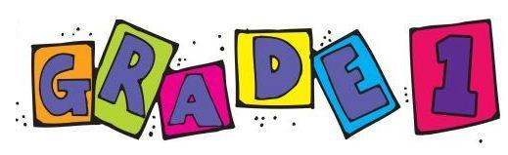
Grade One – 2026-27

The first day is very busy! Please help us out by filling your child’s stash box with scissors, 1 glue stick, 1 eraser, 1 box of crayons, 1 highlighter and 2 sharpened pencils.
All other items are to be put in an extra-large Ziploc bag with your child’s full name. The bags will be collected on the first day of school. Please label all items. Thanks!
- 1- coiled scribbler
- 1- pkg. of 4 Play-Doh containers
- 4- boxes of 24 crayons
- 1- pkg. of markers (non-scented-set of 16)
- 1- pkg. of coloured pencils
- 2 -highlighters
- 1- plastic pencil box
- 1- pair of scissors
- 3- white erasers
- 4- large glue sticks
- 1- bottle of white glue
- 3- pkg. of blue Staedtler (Norica) pencils (these come already sharpened).
- 1 - deck of playing cards
- 12 white board markers (black/blue preferred)
- 1-1/2 lined 1/2 blank exercise book (Staples – yellow or green)
- 7- duo-tangs (red, blue, green, yellow, orange, purple, black)
- 3 pocket folders with no prongs (blue, red, black)
- 2- plastic folders with pockets and prongs (orange and red)
- 5 - unlabelled ziploc large bags
- 1- pair of indoor sneakers (non-marking soles and labelled)
- 1- Change of clothes (in a labelled Ziploc that is kept in backpack)

