Millwood Elementary School

Supply List

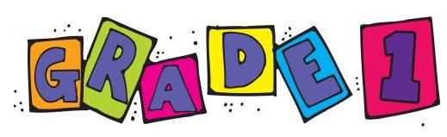Grade One – 2023-24

The first day is very busy! Please help us out by filling your child’s stash box with scissors, 1 glue stick, 1 eraser, 1 box of crayons, and 2 sharpened pencils.

All other items are to be put in an extra-large Ziploc bag with your child’s full name. The bags will be collected on the first day of school. Please label all items. Thanks!

* **1– set of headphones for iPad in a labelled Ziploc bag**
* **1- coiled scribbler**
* **1- pkg. of 4 Play-Doh containers**
* **2- boxes of 24 crayons**
* **2- pkg. of markers (non-scented-set of 16)**
* **1- pkg. of coloured pencils**
* **1- plastic pencil box**
* **1- pair of scissors**
* **2- white erasers**
* **4- large glue sticks**
* **1- bottle of white glue**
* **1- pkg. of blue Staedtler (Norica) pencils (these come already sharpened).**
* **1- personal-sized whiteboard**
* **2- pkg. of 4 white board markers**
* **1-1/2 lined 1/2 blank exercise book (Staples)**
* **4- duo-tangs (red, blue, green, yellow)**
* **1- orange plastic folder with pockets and prongs**
* **1- pair of indoor sneakers (non-marking soles and labelled)**
* **1- Change of clothes (in a labelled Ziploc)**