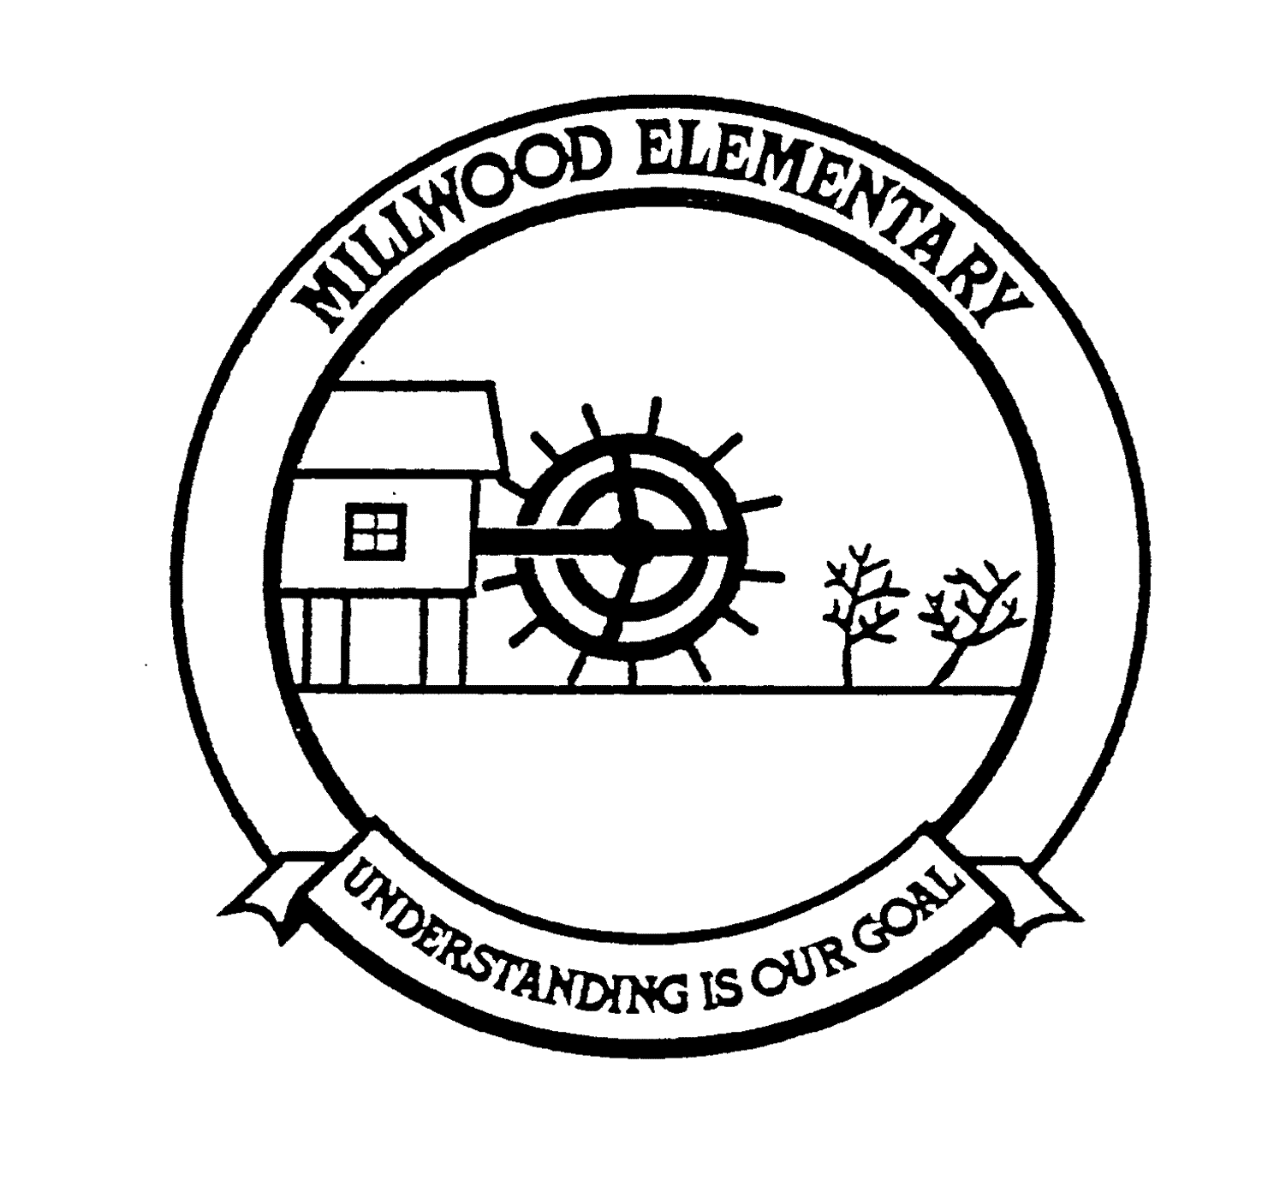  Office: 902-864-7510  Safe Arrival: 902-864-6774  Website: https://mle.hrce.ca/ | Millwood Elementary School  Newsletter  March 2020
Upcoming Dates:
- March 16th-20th: March Break
- March 25th: Assessment and Evaluation Day
- April 1st: Parent teacher evening interviews
- April 2nd: PD in the AM and PT in the Afternoon
- April 8th: Report cards sent home
- April 10th: Good Friday
- April 13th: Easter Monday
- May 6th: Primary Orientation

Part or Full Time Lunch Monitors Needed
We pay our lunch monitors to supervise the children during the lunch hour and we are in need of more lunch monitors. If you have some spare time or you know of someone in the community who might be interested please contact the office at 902-864-7510 or via email at mes@hrce.ca for more information. Our lunch hour is 11:30-12:30. We welcome any interest even if it is only a couple days a month. Thank you!

Registration for New Students
We continue to take registrations for pre-primary and all other students for the upcoming school year. If you know of someone in the community who has yet to register their child, please encourage them to stop by the school to do so. Thank you!

Field Trips: All Volunteers: Important Procedures
Volunteers play an important role in the development of a positive school climate. We welcome parent/community volunteers! Just a reminder that all parent/community volunteers need to have both criminal records check and child abuse registry searches completed prior to volunteering on field trips. If you have any questions, please contact the office and we will be happy to assist you.

Chinese Student Visit
I recently received confirmation that the group of students from China will definitely not be travelling in the month of March. The HRCE will continue to monitor the global situation and will determine if a visit later in the school year may be possible.

Nova Scotia Oral Health Program for Children
Did you know the Nova Scotia Children’s Oral Health program covers annual basic dental care for all children 14 years of age and under with a valid MSI health card?
Once a year, this includes:
- One routine dental exam
- One fluoride application (a second application may be eligible in some cases)
- Two routine x-rays
- In addition to the above, one preventive service – for example, brushing and flossing instruction, and/or cleaning
- Molar sealants, fillings and necessary extractions are also covered by the program.
For more information on this program, visit: novascotia.ca/dhw/children-dental/

Michelle Andrews
Principal

